PROJECT REPORT
Global Electronics Retailer
Business Insights & Recommendations
Tools used: Excel, Power BI, SQL, Python
Project objective: Analyze sales performance, profitability, products, markets, and customer behavior to identify business opportunities and recommend data-driven actions.
1. Executive Summary
The Global Electronics Retailer project analyzes sales data to understand overall business performance, identify key contributors to profitability, and explore customer purchasing patterns.
The recorded analysis reports $55.76 million in revenue, $32.66 million in profit, and a 58.58% profit margin across 26,326 distinct orders. Customer segmentation identifies repeat customers, one-time customers, and customers with no recorded orders.
The product analysis highlights Computers as a major contributor to total profit. The market analysis identifies the United States as the largest country contributor by revenue. The analysis also identifies missing delivery dates as a data-quality limitation that should be investigated before drawing operational conclusions about delivery performance.
Excel was used to summarize business performance, while Power BI provides interactive dashboards for exploring executive KPIs, product and store performance, and customer insights.

2. Key Performance Indicators
Total Revenue
$55.76M
Total Profit
$32.66M
Profit Margin
58.58%
Distinct Orders
26,326
Average Order Value
$2,117.47
Repeat Customers
7,272
One-time customers
4,615
Customers with no recorded orders
3,379

3. Business Insights
Insight 1: Overall business performance
The business recorded $55.76 million in revenue and $32.66 million in profit, with a profit margin of 58.58%.
Business interpretation: Revenue and profit together provide a stronger picture of performance than revenue alone. The margin indicates the proportion of recorded revenue represented by recorded profit.
Recommendation: Monitor revenue, profit, and profit margin together each month. Investigate periods where revenue increases but profitability does not improve at the same rate.
Insight 2: Repeat customers contribute significantly to order activity
The analysis identifies 7,272 repeat customers and 4,615 one-time customers. A further 3,379 customers in the customer master have no recorded orders.
Previously calculated results indicate that repeat customers account for approximately 82.47% of distinct orders.
Business interpretation: Repeat customers are important to the retailer's recorded order activity. Customer count and order count should be considered separately because one customer may place multiple orders.
Recommendations:
- Introduce customer loyalty and repeat-purchase campaigns.
- Analyze which products and categories are frequently purchased by returning customers.
- Track repeat-purchase rate, revenue per customer, and orders per customer.
- Investigate why some customers in the master table have no recorded purchases.

Insight 3: Computers are a major profit contributor
The Computers category contributes approximately 34.5% of total recorded profit.
Business interpretation: Computers are a key category in the retailer's profit mix. A significant contribution from one category makes its performance important to the overall business.
Recommendations:
- Monitor Computers category revenue, profit, and margin.
- Maintain appropriate inventory for high-performing products.
- Compare the profitability of individual products within the category.
- Evaluate opportunities to improve other categories without sacrificing their strategic role.
Insight 4: Market performance varies
The United States is the largest recorded country contributor by revenue, at approximately $23.76 million. Other significant contributors include the Online market, the United Kingdom, Germany, and Canada.
Country/market | Revenue
United States | $23.76M
Online | $11.40M
United Kingdom | $5.75M
Germany | $4.25M
Canada | $3.61M
Business interpretation: Revenue is concentrated in a few major markets. However, high revenue does not automatically mean the highest margin or strongest profitability.
Recommendations:
- Compare markets by revenue, profit, profit margin, and average order value.
- Investigate lower-revenue markets to identify realistic growth opportunities.
- Keep Online separate from geographic-country comparisons because it represents a channel/market label rather than a country.
- Use the Power BI market visual to explore differences across the available markets.
Insight 5: Product performance is concentrated among leading products
The top 10 products by revenue generated approximately $4.30 million combined. Several of the leading products are desktop computers, with an HDTV product also appearing among the top performers.
Business interpretation: A relatively small group of products contributes a meaningful amount of sales. Identifying these products helps the business focus its inventory and product-performance monitoring.
Recommendations:
- Monitor the revenue and profitability of top-selling products.
- Avoid ranking products on revenue alone; include profit and margin in the assessment.
- Review stock availability and sales trends for leading products.
- Examine whether the business depends heavily on a small number of products.
Insight 6: Revenue trends need careful interpretation
The earlier annual analysis recorded increasing revenue from 2016 through 2019, followed by lower totals in 2020 and 2021. However, the 2021 data only extends through February 20.
Business interpretation: The 2021 figure represents a partial year and cannot be compared directly with full-year totals. The lower value should not be interpreted as evidence of a full-year business decline.
Recommendations:
- Compare the same months across different years.
- Use the monthly revenue trend in Power BI to investigate changes over time.
- Clearly label partial-year data.
- Treat forecasts based on assumed growth rates as scenarios rather than guaranteed outcomes.

Insight 7: Missing delivery dates limit operational analysis
Approximately 79.06% of Sales records were identified as having missing delivery dates in the recorded validation checks.
Business interpretation: This level of missingness limits the records available for measuring delivery duration. It does not, by itself, establish that the sales records are invalid or that deliveries were late.
Recommendations:
- Investigate why delivery dates are missing.
- Determine whether the missing values relate to particular order types or periods.
- Improve data-entry or system controls where appropriate.
- Report delivery-time statistics with the number of records included in the calculation.
4. Power BI Dashboard Overview
The Power BI report contains three pages designed for different business questions.
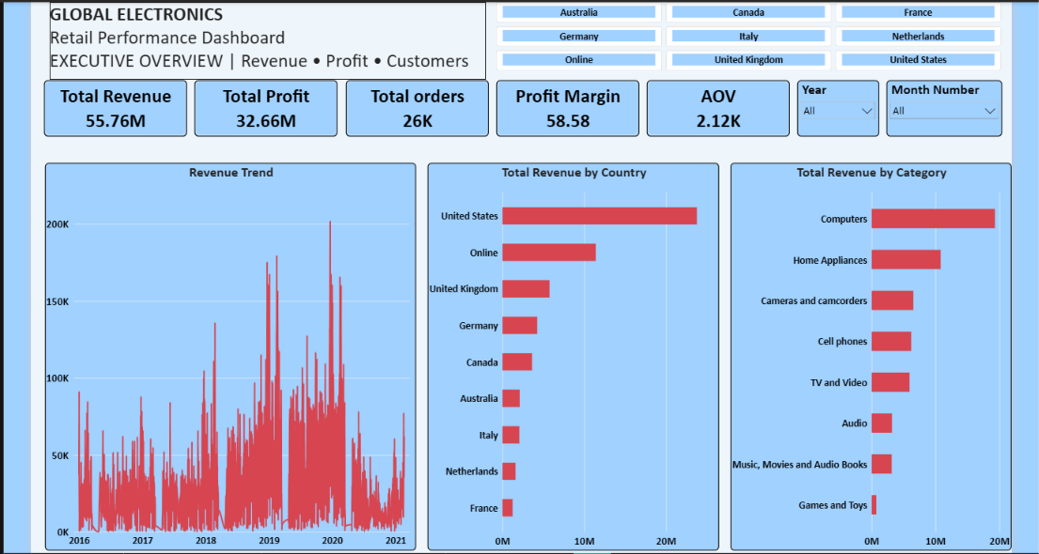
Page 1 — Executive Overview
Provides revenue, profit, margin, order count, and average order value KPIs, alongside monthly revenue trends, revenue by country/market, and revenue by product.
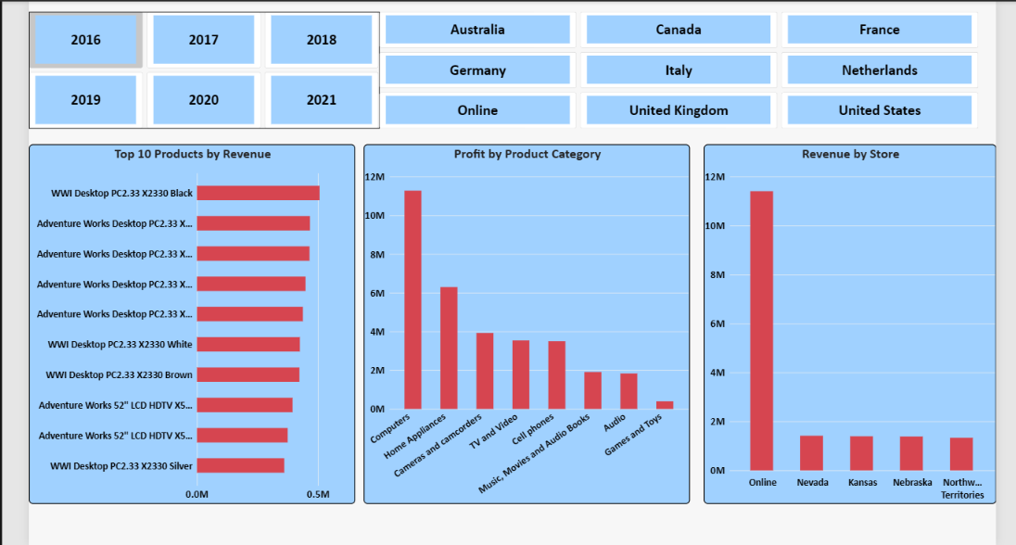
Page 2 — Product & Store Performance
Shows top products by revenue, profit by product category, and leading stores by revenue to support product and store comparisons.
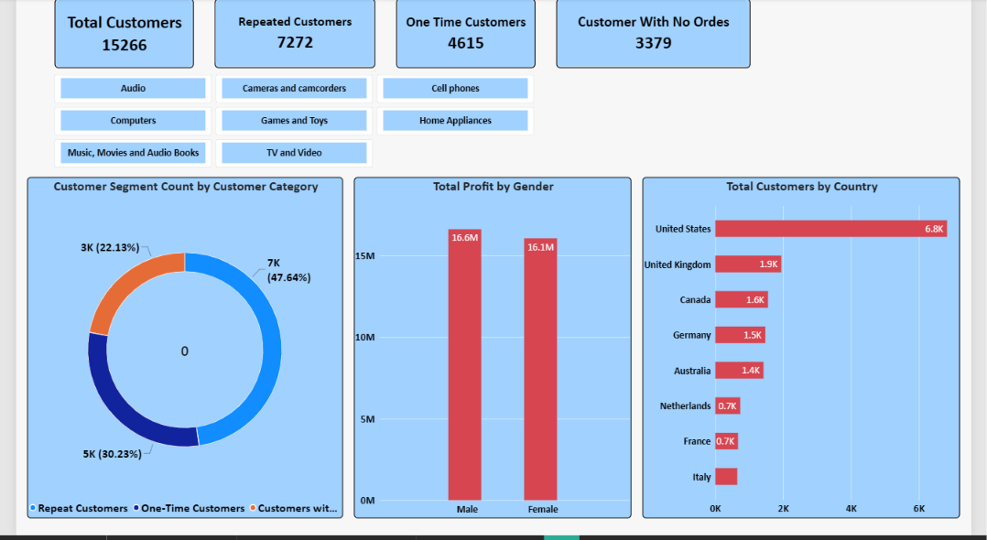Page 3 — Customer Insights
Presents customer totals, repeat and one-time customers, customers with no recorded orders, customer segmentation, and customer distribution by country, Revenue distribution by gender.

5. Business Recommendations Summary
Business area | Recommended action
Overall performance | Track revenue, profit, and margin together.
Customer retention | Develop targeted campaigns to encourage repeat purchases.
Product management | Monitor leading products by revenue, profit, and margin.
Category strategy | Protect the Computers category's contribution while evaluating other categories.
Market strategy | Compare markets using both sales and profitability measures.
Data quality | Investigate missing delivery dates and monitor completeness.
Trend analysis | Compare equivalent periods and clearly label partial years.
6. Conclusion
The Global Electronics Retailer project demonstrates how business data can be converted into useful findings through Excel analysis and Power BI dashboards.
The analysis highlights overall profitability, the importance of repeat customers, the contribution of the Computers category, differences across markets, and the need to interpret incomplete delivery and time-period data carefully.
These findings can support more informed decisions about customer retention, product management, market performance, and data-quality improvement.

